* LED FADE:-

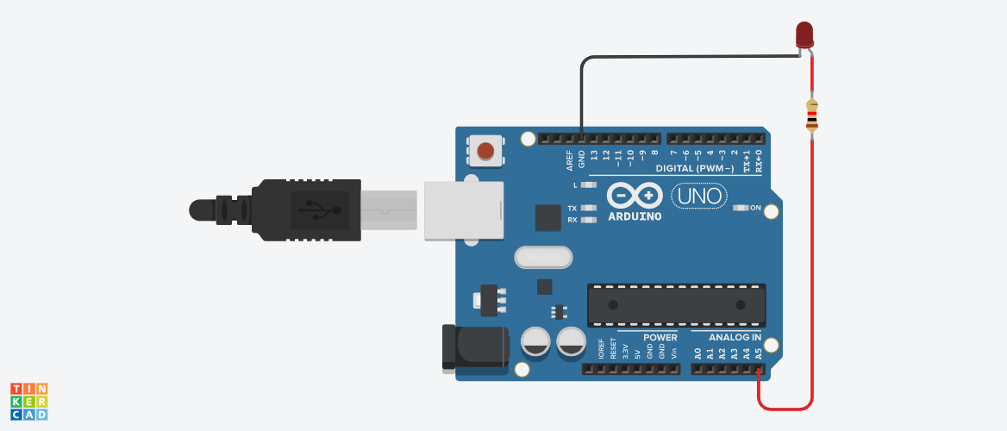

**Circuit diagram**

* **Description :-**

This project is working on fade system of LED. It means LED first start **GLOW slowly** and after LED **OFF Slowly**. It’s called fade system.

* **Application :-** 
  + - * + Home application.
        + In cars as an indicator.
        + In Shopping malls.
        + In festival series decoration.
* **Working Principle:-**

The basic principle of this project is in order to fade our LED off and on, **gradually increase our PWM value from 0 (all the way off) to 255 (all the way on), and then back to 0 once again to complete the cycle**.

* .**Circuit Connection :-**

* Connect the **anode** (the longer, positive leg) of your LED to digital output pin 9 on your board through a 220 ohm resistor. Connect the **cathode** (the shorter, negative leg) directly to ground.

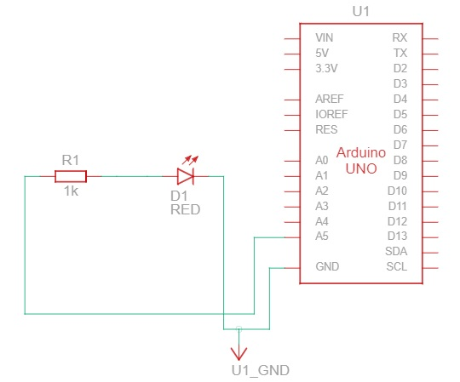

* Component List :-



* **CODES :-**

// C++ code

//

int BRIGHTNESS = 0;

int unnamed = 0;

int i = 0;

void setup()

{

pinMode(A5, OUTPUT);

}

void loop()

{

for (BRIGHTNESS = 0; BRIGHTNESS <= 255; BRIGHTNESS += 5) {

digitalWrite(A5, HIGH);

delay(30); // Wait for 30 millisecond(s)

}

for (BRIGHTNESS = 255; BRIGHTNESS >= 0; BRIGHTNESS -= 5) {

digitalWrite(A5, LOW);

delay(30); // Wait for 30 millisecond(s)

}

}

* **BLOCKCODES :-**

